Detour Maze scoring Protocol

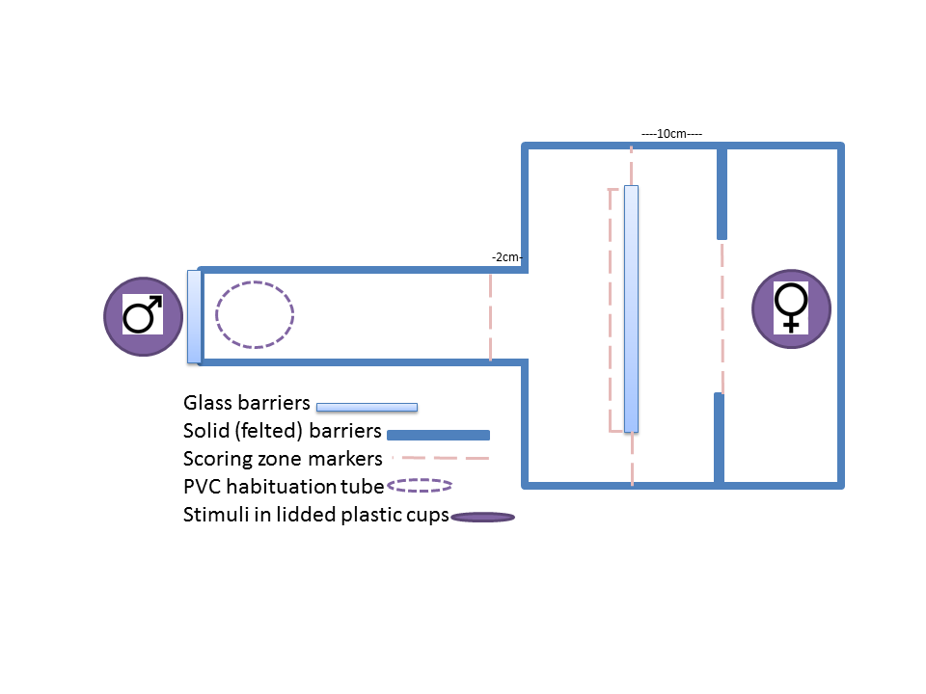

Measurements:

1. Time to end of alley (2cm before physical end, once mouth passes)
2. Time to contact barrier or be within 1 cm of barrier (once mouth passes)
3. Time to go around barrier (once *all of their body is over*)
   1. (Record as time of first evidence of fish on the other side)
4. Time to enter reward zone
5. Total time spent in reward zone
6. Full Solution Time = time to enter reward zone - time to approach barrier (#4 - #2)
7. Detour Solution Time = time to go around barrier - time to approach (#3 - #2)

Notes

* start the timer once the PVC pipe is completely out of view
* Measurements #1, 2, and 5 will be used to standardize for motivation
* Measurements # 6 and 7 will be used to determine cognitive flexibility
* Stop timing once the video reaches 10 minutes after the time that scoring began (when PVC was completely out of frame.
  + For example, if PVC was completely out of frame at 0:31 then timing will stop at 10:31.
* All detour videos will be hand-scored by Kelly and one other scorer (no transparencies or grids needed)
* All detour videos will be renamed by a third non-scorer to prevent scorer bias